**PROJECT REPORT ON**

**“FRUIT CLASSIFICATION”**

**Subject – ADVANCED MACHINE LEARNING**

**Submitted By -**

|  |  |  |  |
| --- | --- | --- | --- |
| **Name** | **Prn No** | **Roll No** | **Email** |
| **Utkarsh Bhalsing** | **22111267** | **322011** | **utkarsh.22111267@viit.ac.in** |
| **Yash Gavit** | **22110075** | **322024** | **yash.22110075@viit.ac.in** |
| **Akash Gawade** | **22110169** | **322025** | **akash.22110169@viit.ac.in** |
| **Atharva Valsange** | **22111268** | **322063** | **atharva.22111268@viit.ac.in** |

**Guided By : - Prof. Disha Wankhede**

**Table of Contents**

1. Introduction

1.1 Purpose

1.2 Scope

1.3 Definitions, Acronyms, and Abbreviations

1.4 References

1.5 Overview

2. Overall Description

2.1 Product Perspective

2.2 Product Features

2.3 User Classes and Characteristics

2.4 Operating Environment

2.5 Design and Implementation Constraints

2.6 Assumptions and Dependencies

3. Specific Requirements

3.1 Functional Requirements

3.2 Supplementary Requirements

3.3 Non-Functional Requirements

4. Risk Analysis

5. Supporting Information

4.1 Data Collection and Preprocessing

4.2 Model Evaluation Metrics

# 1. Introduction

**1.1 Purpose**

Fruits contain vitamins and dietary fibres, a vital source of the human diet. Different types of more than 2,000 fruits are found worldwide, but most people are familiar with only 10% of them. According to fruit production statistics, million metric tons of fruits were produced worldwide in 2021, from which the largest producing countries are China, India, and Brazil. Te advanced agricultural fruit recognition system with a simple camera or sensor will play an excellent role for farmers and general people. In this modern era of technological advancements, fruit classifcation and recognition systems can be used for kids’ educational purposes, which interest them greatly. The latest advanced computer vision technology with the utilization of deep neural networks can be used for object discovery and semantic picture division.

**1.2 Scope**

The scope of fruit classification involves using computer vision and machine learning techniques to categorize fruits based on various attributes. This includes image-based classification, feature extraction, and the utilization of different machine learning models. Tasks range from creating annotated datasets to developing real-time classification systems. Challenges include handling variability in fruit appearance and addressing limitations in computational resources. Fruit classification has diverse applications in agriculture, retail, healthcare, and education, with considerations for ethical implications.

* 1. **Definitions, Acronyms, and Abbreviations**

1. CNN: Convolutional Neural Network - Deep learning model for image classification tasks.

2. SVM: Support Vector Machine - Learning model for classification and regression.

3. ML: Machine Learning - Field of AI focusing on algorithms learning from data.

4. CV: Computer Vision - Discipline enabling computers to interpret visual information.

5. ROI: Region of Interest - Specific area in an image for analysis.

6. RGB: Red, Green, Blue - Colour model used in digital imaging.

7. PCA: Principal Component Analysis - Technique for dimensionality reduction.

8. IoU: Intersection over Union - Metric for object detection accuracy.

9. TP, TN, FP, FN: True Positive, True Negative, False Positive, False Negative - Metrics for classification evaluation.

* 1. **References**

The information on fruit classification, including definitions, acronyms, and abbreviations, is commonly found in various academic resources, including textbooks, research papers, online courses, and technical documentation of machine learning and computer vision frameworks. Additionally, relevant information can be sourced from journals, conferences, and online databases focused on agricultural science, food technology, and computer vision applications.

* 1. **Overview**

The topic of fruit classification encompasses the use of machine learning and computer vision techniques to categorize fruits based on various attributes such as shape, colour, and texture. This involves developing algorithms and models capable of recognizing and distinguishing between different types of fruits, often using image data as input. Fruit classification has applications in agriculture, food processing, retail, and healthcare, with potential benefits including improved quality control, automated sorting, and enhanced dietary monitoring. Key components of fruit classification include dataset creation, feature extraction, model training, and evaluation. Challenges include variability in fruit appearance, dataset labelling, and computational complexity. Overall, fruit classification represents an interdisciplinary field at the intersection of computer science, agricultural science, and consumer technology, offering opportunities for innovation and practical applications across various domains.

**2. Overall Description**

**2.1 Product Perspective**

The product perspective of fruit classification involves understanding how fruit classification systems integrate into larger products or applications. These systems are essential components of agricultural sorting machines, mobile apps, retail inventory management, food quality assurance processes, and healthcare nutrition tracking. Fruit classification solutions must be interoperable, scalable, and user-friendly, with considerations for data privacy, regulatory compliance, and cost-effectiveness.

**2.2 Product Features**

The product features of a fruit classification system include image processing, feature extraction, and the use of machine learning models for accurate classification. It should support multi-class classification, real-time processing, and offer high accuracy and robustness. Additionally, an intuitive user interface, scalability, customization options, and integration with existing systems are essential. Feedback mechanisms and security measures are also important for continuous improvement and data protection. These features collectively ensure the effectiveness and usability of the system across various applications.

**2.3 User Classes and Characteristics**

User classes and characteristics in fruit classification encompass various stakeholders with distinct roles and requirements:

1. Farmers and Agricultural Workers: Require efficient sorting systems for optimizing yield.

2. Food Processing Industry Professionals: Need accurate classification for consistent product quality.

3. Retailers and Distributors: Benefit from real-time classification for inventory management.

4. Consumers: Seek information on fruit types, nutrition, and quality through user-friendly platforms.

5. Healthcare Professionals: Use classification systems for dietary monitoring and personalized nutrition.

6. Researchers and Academics: Require access to datasets and tools for fruit classification research.

7. Software Developers and Engineers: Need robust frameworks and APIs for developing classification systems.

8. Regulatory Bodies and Standards Organizations: Ensure compliance with industry standards and regulations.

Understanding these user classes and their characteristics is crucial for designing effective fruit classification systems tailored to their specific needs and preferences.

**2.4 Operating Environment**

The operating environment of fruit classification systems encompasses various factors:

1.Physical Environment: Indoor or outdoor settings with varying temperature and humidity levels.

2. Equipment and Infrastructure: Hardware components and networking requirements.

3. Data Environment: Availability of image datasets for training and evaluation.

4. Regulatory Environment: Compliance with food safety and data protection regulations.

5. Technological Environment: Software dependencies and integration with existing systems.

6. Operational Constraints: Real-time processing and resource limitations.

7. Security Environment: Data security measures and protection against cyber threats.

8. Human Factors: User interface design, training, and support for system users.

**2.5 Design and Implementation Constraints**

Design and implementation constraints in fruit classification encompass various limitations and factors that impact system development and deployment:

1. Computational Resources: Constraints on processing power, memory, and energy efficiency.

2. Data Availability and Quality: Challenges with dataset size, variability, and imbalanced distributions.

3. Algorithmic Complexity: Balancing model complexity, training time, and computational efficiency.

4. Technological Constraints: Dependencies on software libraries, compatibility issues, and system integration.

5. Regulatory and Ethical Considerations: Compliance with privacy regulations, fairness, and bias mitigation.

6. Scalability and Maintenance: Ensuring scalability, ongoing maintenance, and support for the deployed system.

7. User Interface and Experience: Designing user-friendly interfaces and ensuring interpretability of classification results.

Addressing these constraints is essential for developing and deploying effective fruit classification systems that meet performance requirements and user needs while operating within given limitations.

**2.6 Assumptions and Dependencies**

Assumptions and dependencies in fruit classification shape system development and operation:

1. Assumptions:- Data consistency, feature relevance, model generalization, and label accuracy are assumed.

2. Dependencies:- Reliance on data, technology, resources, and environmental factors.

3. External Dependencies:- Reliance on external data sources, APIs, libraries, and regulatory compliance.

4. Domain-Specific Assumptions:- Assumptions regarding fruit homogeneity, environmental uniformity, and limited variability.

**3. Specific Requirements**

**3.1 Functional Requirements**

Functional requirements in fruit classification define what the system must do to meet user needs:

1. Image Acquisition: Obtain fruit images from cameras or databases.

2. Preprocessing: Enhance image quality through resizing and noise reduction.

3. Feature Extraction: Extract relevant features like color and texture.

4. Model Training: Train machine learning models with labeled datasets.

5. Classification: Categorize fruits based on learned patterns.

6. Real-time Processing: Provide immediate classification feedback.

7. Multi-class Classification: Classify fruits into multiple categories.

8. Accuracy and Performance: Achieve high classification accuracy and performance.

9. Robustness: Ensure consistent performance across different environments.

10. Scalability: Handle large volumes of data and system usage.

11. User Interface: Provide an intuitive interface for user interaction.

12. Feedback Mechanisms: Incorporate mechanisms to improve classification accuracy.

13. Security: Implement measures to protect data and ensure user privacy.

**3.2 Supplementary Requirements**

**Supplementary requirements in fruit classification add value to the system beyond its core functionalities. These include:**

1. Cross-platform Compatibility: Support for different devices and operating systems.

2. Localization and Internationalization: Adaptability to various languages and regional conventions.

3. Accessibility: Ensuring usability for users with disabilities.

4. Offline Mode: Capability to function without internet connectivity.

5. Customization Options: Settings adjustment for user-specific needs.

6. Error Handling: Robust mechanisms for managing system errors.

7. Documentation and Help Resources: Comprehensive guides for user assistance.

8. Performance Metrics and Logging: Monitoring and logging system events and performance.

9. Data Privacy and Compliance: Adherence to privacy regulations and encryption of sensitive data.

10.Continuous Improvement and Updates: Mechanisms for feedback collection, system monitoring, and regular updates.

11. Integration with External System: Compatibility with other software for seamless data exchange.

12. Testing and Validation: Rigorous testing processes to ensure system quality and reliability.

**3.3 Non-Functional Requirements**

Non-functional requirements in fruit classification outline the system's operational, performance, security, usability, maintainability, and regulatory aspects:

1. Performance: Defines response time, throughput, and scalability requirements.

2. Reliability: Ensures availability, fault tolerance, and recoverability.

3. Security: Specifies authentication, data protection, and auditability measures.

4. Usability: Focuses on user interface design, accessibility, and training/documentation.

5. Maintainability: Addresses modifiability, portability, and documentation for system maintenance.

6. Regulatory Compliance: Ensures adherence to data privacy and food safety regulations.

**4. Risk Analysis**

Risk analysis in fruit classification involves identifying potential risks and their impacts on the system's development, deployment, and operation. Here's how it applies to fruit classification:

1. Data Quality:

- Risk: Poor quality or insufficient quantity of labeled data can lead to inaccurate classification models.

- Impact: Decreased classification accuracy and reliability, potentially leading to incorrect fruit sorting or misclassification.

2. Algorithm Performance:

- Risk: Ineffective feature extraction or classification algorithms may result in suboptimal performance.

- Impact: Reduced classification accuracy, slower processing times, and compromised system reliability.

3. Environmental Factors:

- Risk: Variability in environmental conditions (e.g., lighting, background) can affect image quality and system performance.

- Impact: Inconsistent classification results and decreased system robustness in real-world settings.

4. Technological Constraints:

- Risk: Dependencies on specific hardware or software technologies may limit system scalability or compatibility.

- Impact: Difficulty in system deployment, increased development costs, and potential constraints on system performance.

5. Regulatory Compliance:

- Risk: Failure to comply with data privacy or food safety regulations may result in legal consequences or reputational damage.

- Impact: Fines, legal penalties, loss of trust from users, and damage to the system's reputation.

6. Security Vulnerabilities:

- Risk: Security vulnerabilities in the system may lead to unauthorized access, data breaches, or malicious attacks.

- Impact: Compromised data integrity, loss of sensitive information, and disruption of system operation.

7. User Acceptance:

- Risk: User dissatisfaction due to poor usability, lack of features, or inaccurate classification results.

- Impact: Reduced user adoption, negative feedback, and potential abandonment of the system.

8. Resource Constraints:

- Risk: Limited availability of resources (e.g., budget, manpower) may hinder system development or maintenance efforts.

- Impact: Delays in project timelines, compromised system quality, and increased risk of project failure.

9. Integration Challenges:

- Risk: Difficulty integrating the classification system with existing infrastructure or external systems.

- Impact: Disrupted workflow, data inconsistency, and reduced system interoperability.

10. Ethical Considerations:

- Risk: Ethical concerns related to bias, fairness, and transparency in classification algorithms.

- Impact: Public backlash, damage to reputation, and legal ramifications.

**4. Supporting Information**

**4.1 Data Collection and Preprocessing**

Datasets. In this work, we used two types of datasets of various categories of fruits.. Tis open-source. Tere are approximately 30 to 40 images in each category with a considerable variation of added noises. A significant contribution of this work is to present a dataset of various fruits images that we had obtained and captured by smartphone cameras. In this second dataset, we work with eight classes of fruits, which are primarily available in Bangladesh. As illustrated in Table 2, this custom dataset contains "Apple Golden 1","Avocado","Banana","Cherry 1","Cocos","Kiwi","Lemon","Mango","Orange"

,we assigned 80% of the images for the training, 10% for the testing part, and 10% for the validation part. Next, traditional data augmentation techniques, e.g., projection, rotation, scaling, changing brightness and contrast, etc., are applied to both datasets to enhance the efficiency of the deep learning techniques.

Preprocessing steps in fruit classification involve enhancing and standardizing raw input data (fruit images) before feeding them into the classification model. Common steps include resizing, normalization, colour space conversion, cropping, noise reduction, contrast enhancement, edge detection, histogram equalization, rotation/flipping, data augmentation, feature extraction, and dimensionality reduction. These steps improve data quality, enhance discriminative information, and facilitate better model training and performance**.**

**4.2 Model Evaluation Metrics**

Image capture after model training

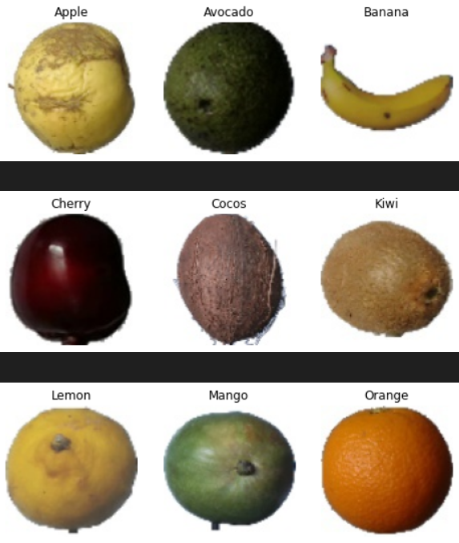

**Accuracy Graph**

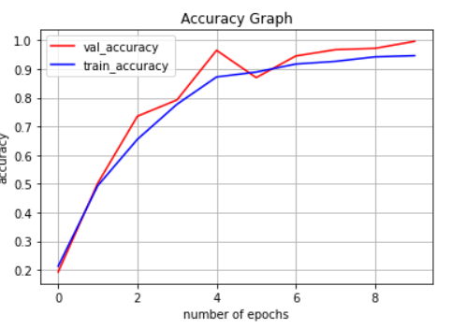

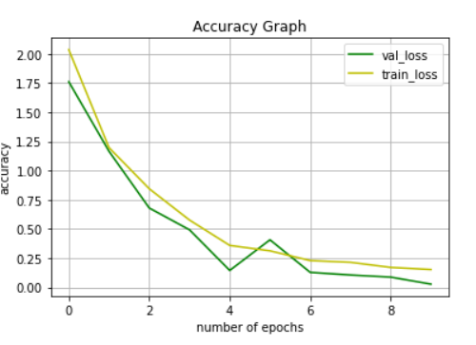

**Confusion Matrix**

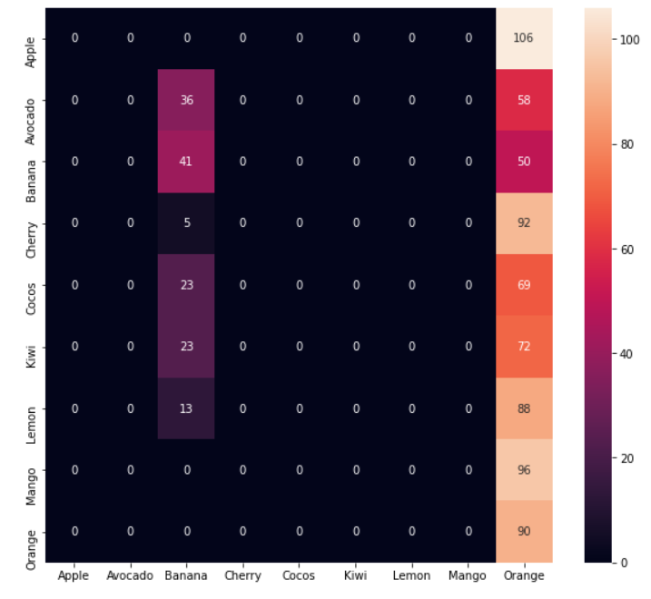

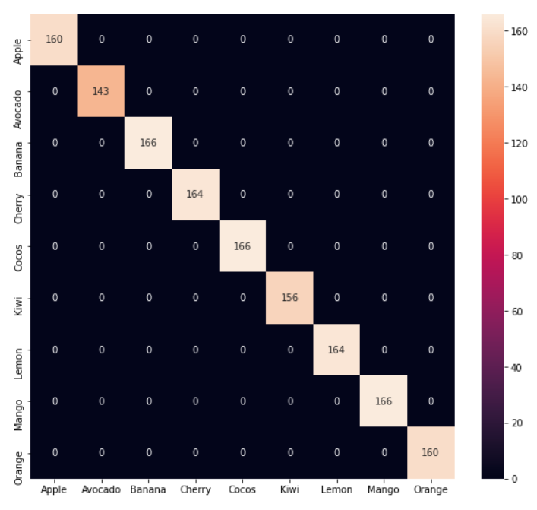

**Conclusion**

In conclusion, fruit classification is a vital task with various applications in agriculture, food processing, and retail. Through the use of machine learning techniques, such as image classification models, fruits can be accurately identified and sorted based on their visual characteristics.

The process involves collecting a large dataset of labeled fruit images, extracting relevant features, training a classification model, and evaluating its performance. Challenges such as data variability, model selection, and deployment considerations need to be addressed to develop robust and reliable fruit classification systems.

Despite these challenges, fruit classification offers significant benefits, including improved efficiency in fruit sorting, enhanced quality control, and better inventory management. As technology continues to advance, the accuracy and effectiveness of fruit classification systems are expected to further improve, enabling broader adoption across various industries.